Bug 1

Broken links

|  |  |  |  |
| --- | --- | --- | --- |
| **Error** | **URL** | **Anchor Text** | **Linked From** |

|  |  |  |  |
| --- | --- | --- | --- |
| [404 Not Found](https://www.deadlinkchecker.com/error-codes.asp?e=404) | <https://alasrgroup.com.pk/career.html> | Careers | <https://alasrgroup.com.pk/chairmans_message.html> |
|  |  |  |  |

|  |  |  |  |
| --- | --- | --- | --- |
| [404 Not Found](https://www.deadlinkchecker.com/error-codes.asp?e=404) | <https://alasrgroup.com.pk/cloud.html> | Downloads | <https://alasrgroup.com.pk/chairmans_message.html> |

|  |  |  |  |
| --- | --- | --- | --- |
| [404 Not Found](https://www.deadlinkchecker.com/error-codes.asp?e=404) | <https://alasrgroup.com.pk/page-search-results.html> | form/action(get) | <https://alasrgroup.com.pk/chairmans_message.html> |

|  |  |  |  |
| --- | --- | --- | --- |
| [404 Not Found](https://www.deadlinkchecker.com/error-codes.asp?e=404) | <https://alasrgroup.com.pk/blog-post.html> | Lorem ipsum dolor sit amet, consectetur adipiscing elit. | <https://alasrgroup.com.pk/index.html> |

|  |  |  |  |
| --- | --- | --- | --- |
| [404 Not Found](https://www.deadlinkchecker.com/error-codes.asp?e=404) | <https://alasrgroup.com.pk/booking.html> | Online Booking &raquo; | [https://alasrgroup.com.pk/project_albums/Al Zohra Classic/album/index.html](https://alasrgroup.com.pk/project_albums/Al%20Zohra%20Classic/album/index.html) |

|  |  |  |  |
| --- | --- | --- | --- |
| [404 Not Found](https://www.deadlinkchecker.com/error-codes.asp?e=404) | <https://alasrgroup.com.pk/img/map-bottom-dark.png> | style: html.dark section.featured.map | <https://alasrgroup.com.pk/css/theme.css> |

|  |  |  |  |
| --- | --- | --- | --- |
| [404 Not Found](https://www.deadlinkchecker.com/error-codes.asp?e=404) | <https://alasrgroup.com.pk/vendor/rs-plugin/images/gradient/g30.png> | style: .tp-button | <https://alasrgroup.com.pk/vendor/rs-plugin/css/settings.css> |

|  |  |  |  |
| --- | --- | --- | --- |
| [404 Not Found](https://www.deadlinkchecker.com/error-codes.asp?e=404) | <https://alasrgroup.com.pk/vendor/rs-plugin/images/gradient/g40.png> | style: .tp-button.big | <https://alasrgroup.com.pk/vendor/rs-plugin/css/settings.css> |

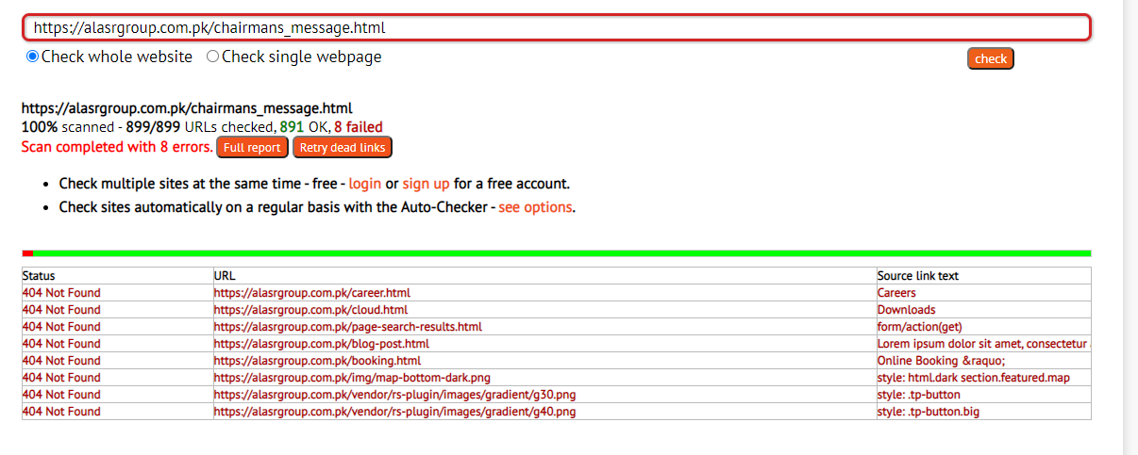

Bug 2



Text is wrong on search bar

Bug3

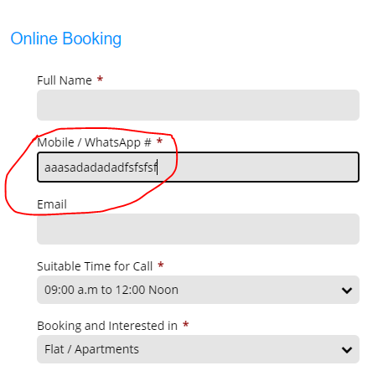

It is supporting alphabet in number text bar

Bug 4

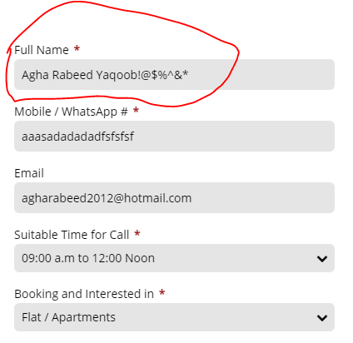

In alphabetic text bar it is allowing to enter special characters

Bug 4

It is supporting special charcters in city and province text bar

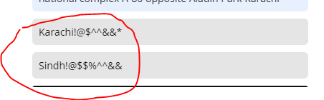

Bug 5

Email validation is missing

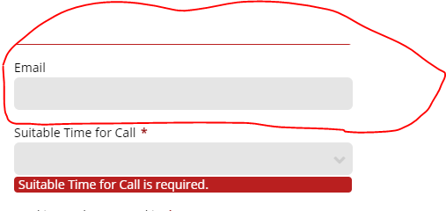

Bug 6

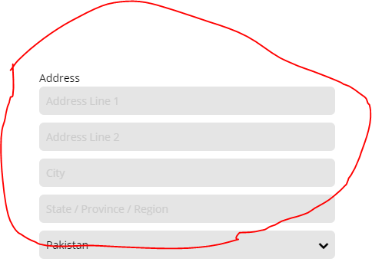

Address , city and state validation is missing

Bug 7

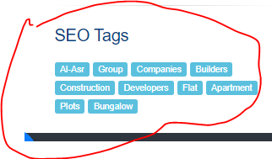

Seo tags should not be their

Bug 8

This text should not be there in website

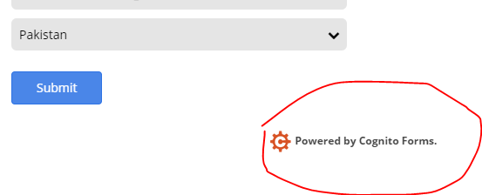

Bug 9

This link is opening my one drive file.

There should be google drive also

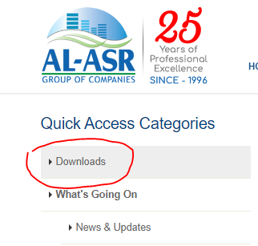

Bug 10





Responsiveness of messenger logo

Bug 11

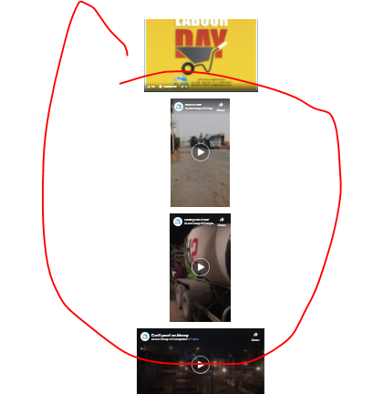

Responsiveness in video bar and rest of the page is missing

Bug 12

Responsiveness is missing in tvc’s commercial

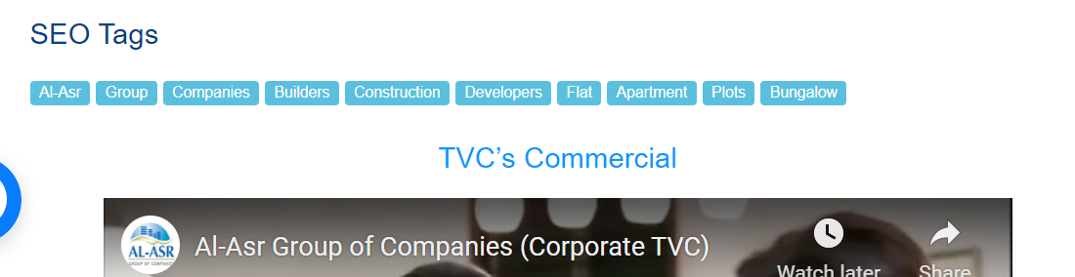

Bug 13

Footer responsiveness

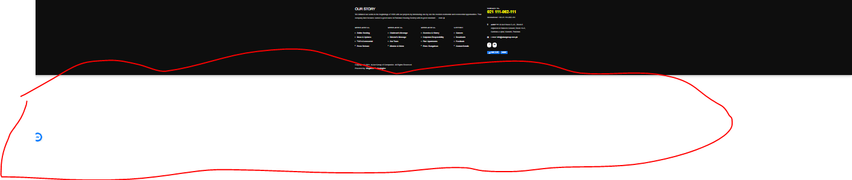

Bug 14

Responsiveness in the header

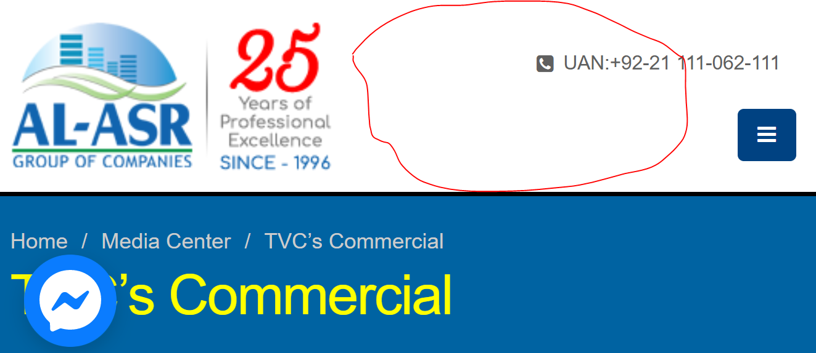

Bug 15

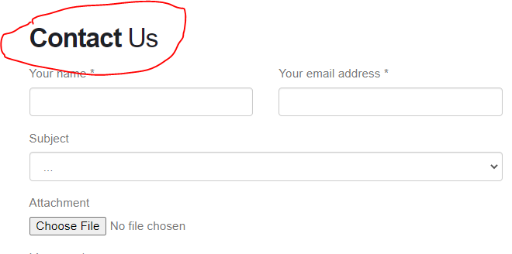

Contact us has different writing font style

Bug 16



Different fonts

Bug 17



Messenger button is missing

Bug 18

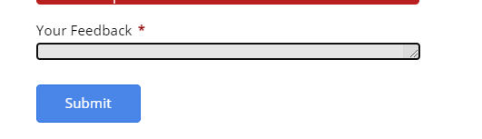

Feedback has alignment issue

Bug 19

No validation on mobile number

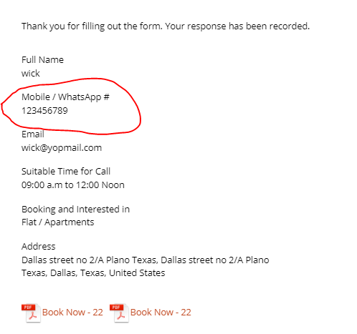

Bug

Provide no validation on mobile phone number

Bug 20

Language should be English

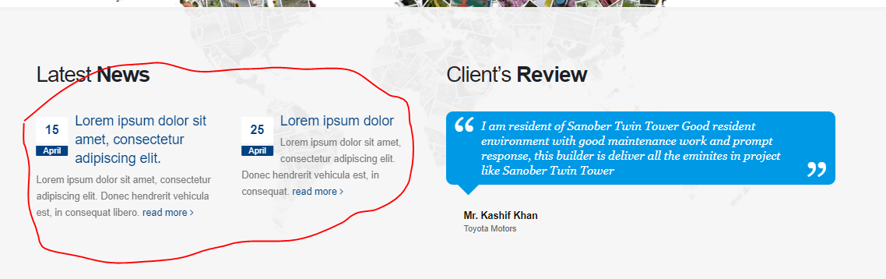

Bug 21

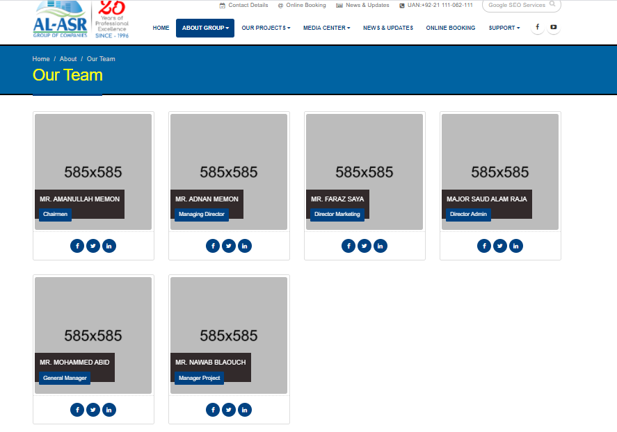

Bug 22

The fb/twitter /linkedin just opening but not their profile and the format of picture is not good from user side

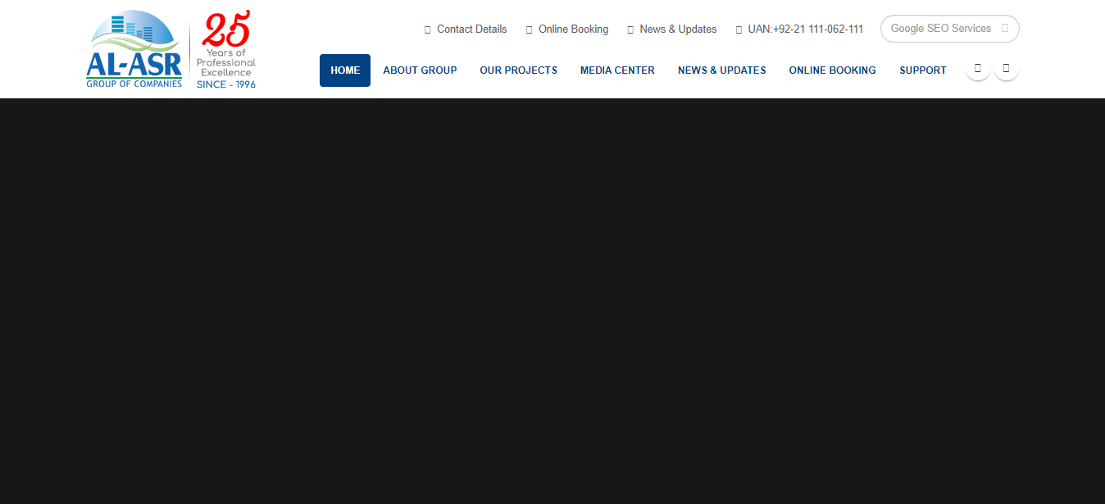

Bug 22

Response time is too late

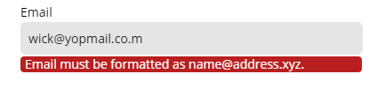

Bug 23

The user experience as for the validation of email is not compliment with the website flow

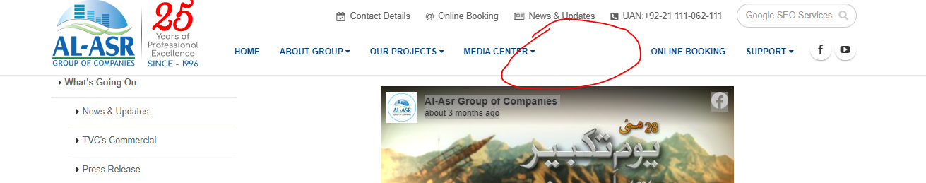

Bug 24

When I scroll side by side media center disappeared

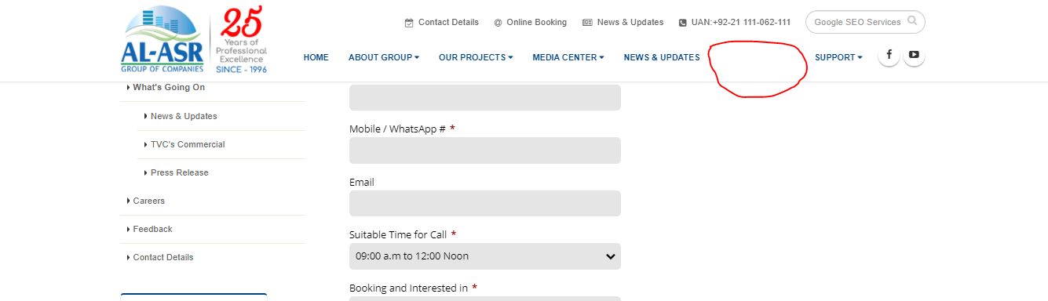

Bug 25

When I scroll side by side online booking disappeared

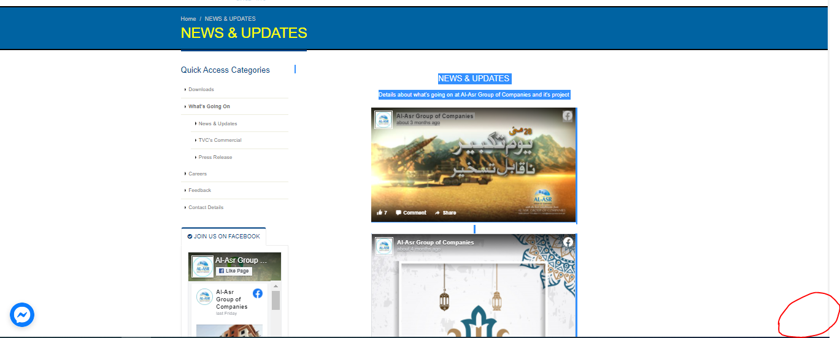

Bug 26

When once scrolls up it would again be showing the scrolling up button

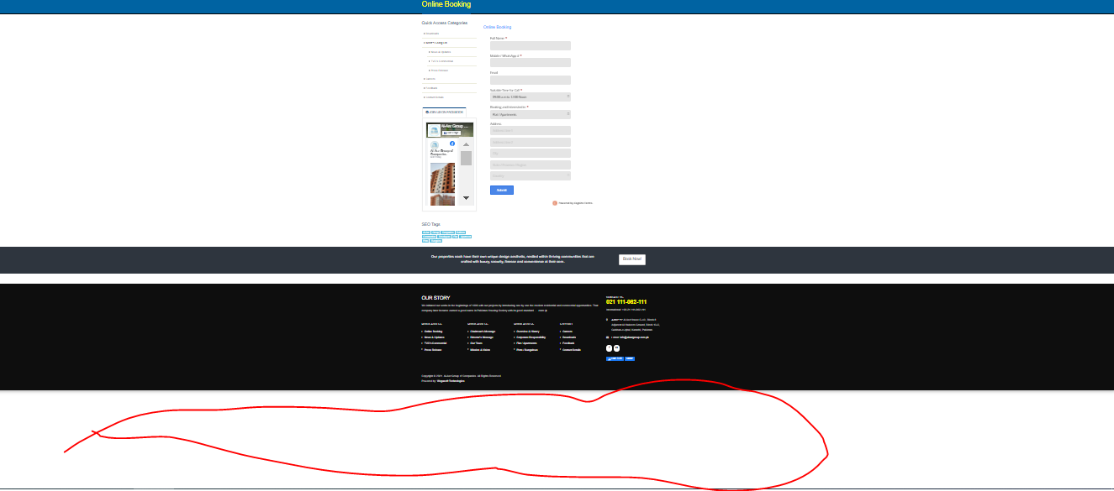

Bug 27

Responsiveness issue



Bug 28

Responsiveness issue



Bug 29

It can’t be able to show the down part of the website

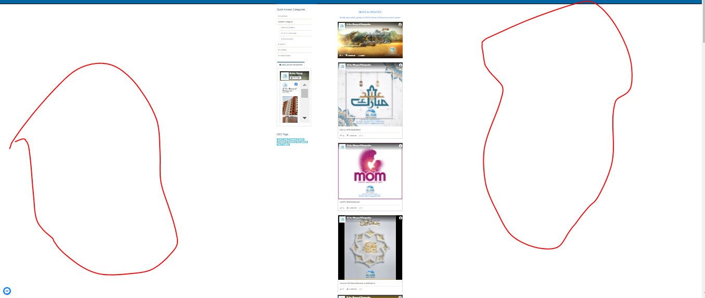

Bug 30

It is empty and unresponsiveness

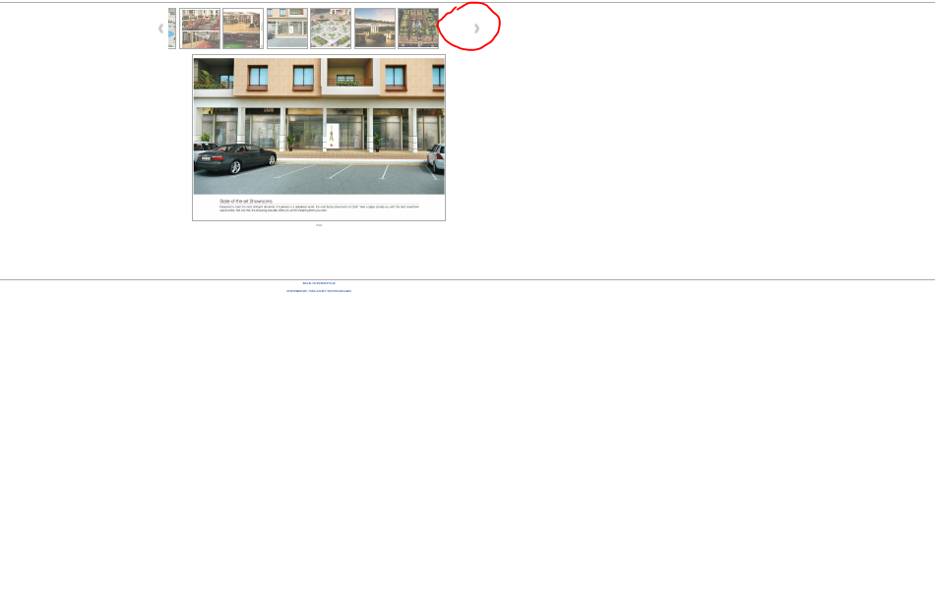

Bug 31

It is dislocated from side

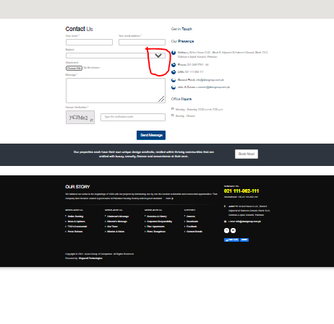

Bug 32

Drop down button responsiveness

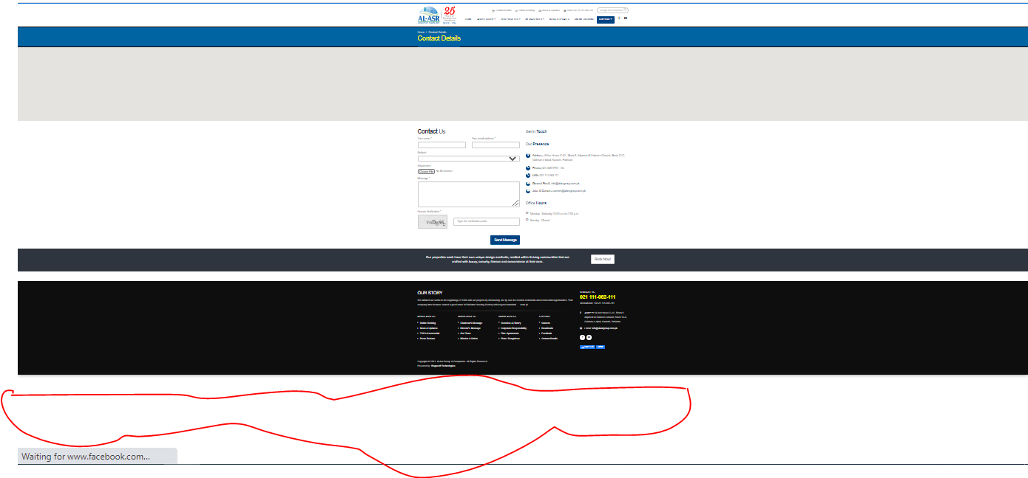

Bug 33

Responsiveness issue

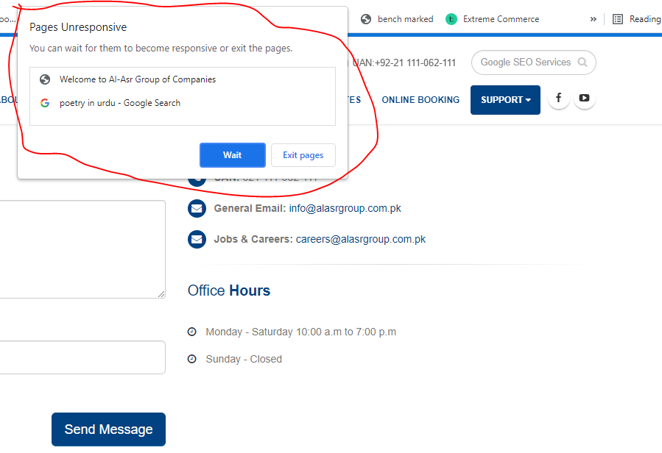

Bug 34

Page unresponsiveness



Bug 35

Unresponsiveness bug



Bug 36

Page unresponsiveness message

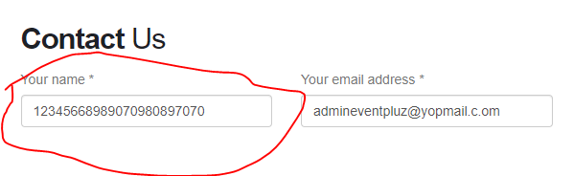

Bug 37

Your name is supporting integers

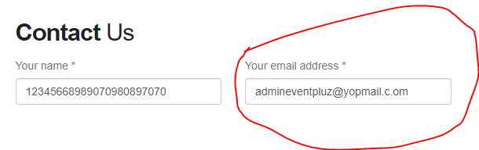

Bug 38

email address don’t have any validation